CYCLE 2

Computer Networks Lab

SHWETA PATIL-1BM19CS156

# WriteaprogramforerrordetectingcodeusingCRC-CCITT(16-bits).

## Program :

def xor1(a,b): x = ""

# print(len(a),len(b)) foriinrange(1,len(a)):

if a[i] ==b[i]: x += "0"

else:

x += "1"

return x

defmodulo2(divident,divisor): divlen =len(divisor)

temp =divident[0:divlen] # print(temp)

while(divlen<len(divident)): if temp[0] == "1":

temp = xor1(temp,divisor)+divident[divlen] else:

temp =temp[1:divlen]+divident[divlen] # print(temp)

divlen+=1 # print(temp)

if temp[0] =="1":

temp=xor1(temp,divisor) # return "0"+temp

# print(len(temp),)

iflen(temp)<len(divisor): return "0"+temp

return temp

def encode(data, key):

append = data+"0"*(len(key)) # print(code)

rem = modulo2(append,key) print("remaindar="+rem) code = data+rem print("code="+code)

# Checking thelogic:

rem = modulo2(code, key)

print("Remaindar we get when we do not have error="+rem) code = code.replace("011","101")

rem = modulo2(code, key)

print("Remaindar we get when we have error="+rem)

def polytobin(string): keys = []

key = ""

foriinstring: if i =='+':

keys.append(int(key[1:])) key =""

continue key += i

if key != "": keys.append(0)

bina = "" j = 0

print(keys)

foriinrange(keys[0],-1,-1): if i ==(keys[j]):

bina += "1"

j += 1

else:

bina +="0" print(bina) return bina

string = input("Enter the key polynomial:\n") key = polytobin(string)

string=input("Enterthedatapolynomial:\n") data = polytobin(string)

print(key, data) encode(data, key)

# Output:

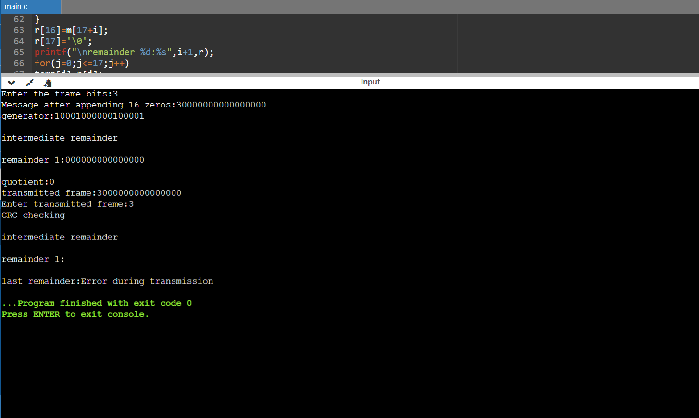

1. **Writeaprogramfordistancevectoralgorithmtofindsuitablepathfor transmission.**

## Program :

class Graph:

definit(self, vertices): self.V = vertices self.graph = []

def add_edge(self, s, d, w): self.graph.append([s, d, w])

def print_solution(self, dist, src, next_hop): print("Routing table for ", src) print("Dest\t Cost \t Next Hop")

for i in range(self.V):

print("{0}\t{1}\t{2}".format(i,dist[i],next_hop[i])) def bellman_ford(self, src):

dist = [99] * self.Vdist[src] = 0 next_hop={src:src}

for _ in range(self.V - 1): for s, d, w in self.graph:

ifdist[s]!=99anddist[s]+w<dist[d]: dist[d]=dist[s]+w

if s == src: next_hop[d] =d

elif s in next_hop: next_hop[d] = next_hop[s]

for s, d, w in self.graph:

if dist[s] != 99 and dist[s] + w <dist[d]: print("Graph containsnegativeweightcycle") return

self.print_solution(dist, src, next_hop)

def main(): matrix = []

print("Enter the no. of routers:") n = int(input())

print("Entertheadjacencymatrix:Enter99forinfinity") for i inrange(0,n):

a=list(map(int,input().split(""))) matrix.append(a)

g = Graph(n)

for i in range(0,n): for j in range(0,n):

g.add_edge(i,j,matrix[i][j])

for k in range(0, n): g.bellman_ford(k)

main()

Output:

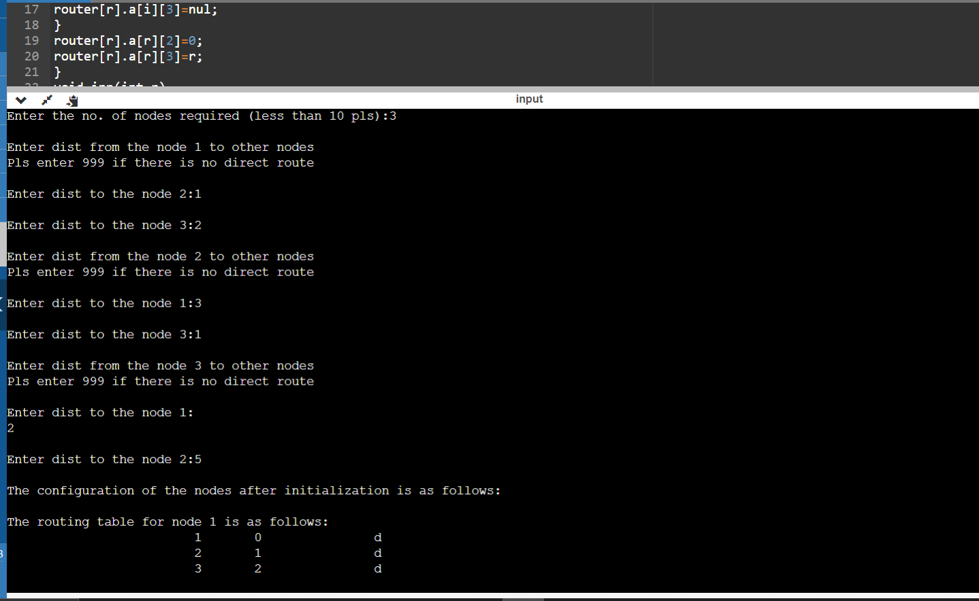

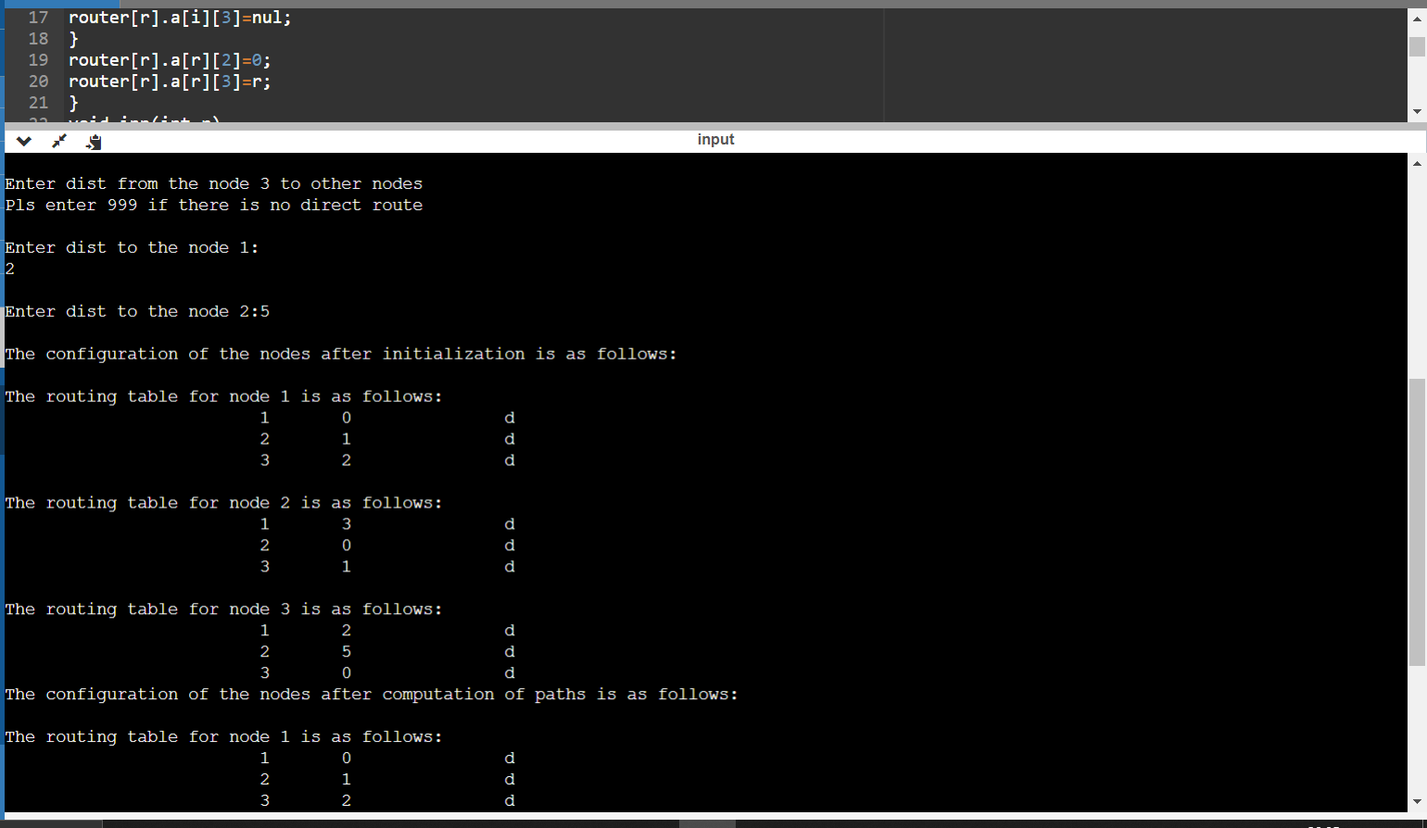

# ImplementDijkstra’salgorithmtocomputetheshortestpathforagiven topology.

## Program:

#include<bits/stdc++.h> using namespace std;

#define V 5

int minDistance(int dist[], bool sptSet[])

{

intmin=9999,min_index; for(intv=0;v<V;v++)

if(sptSet[v]==false&&dist[v]<=min) min=dist[v],min_index=v;

return min_index;

}

void printPath(int parent[], int j)

{

if (parent[j] == - 1) return;

printPath(parent, parent[j]);

cout<<j<<" ";

}

void printSolution(int dist[], int n, int parent[])

{

int src =0;

cout<<"Vertex\t Distance\tPath"<<endl; for (int i = 1; i< V; i++)

{

cout<<"\n"<<src<<" -> "<<i<<" \t "<<dist[i]<<"\t\t"<<src<<" "; printPath(parent, i);

}

}

void dijkstra(int graph[V][V], int src)

{

int dist[V]; bool sptSet[V]; int parent[V];

for (int i = 0; i< V; i++)

{

parent[0] = -1;

dist[i] = 9999; sptSet[i] = false;

}

dist[src] = 0;

for (int count = 0; count < V - 1; count++)

{

intu=minDistance(dist,sptSet); sptSet[u] =true;

for (int v = 0; v <V; v++)

if (!sptSet[v] && graph[u][v] &&dist[u] + graph[u][v] <dist[v])

{

parent[v] = u;

dist[v] = dist[u] + graph[u][v];

}

}

printSolution(dist, V, parent);

}

int main()

{

int graph[V][V];

cout<<"Enterthegraph(Enter99forinfinity):"<<endl; for(int i = 0; i<V; i++)

{

for(intj=0;j<V;j++) cin>>graph[i][j];

}

cout<<"Enter the source: "<<endl; int src;

cin>>src;

dijkstra(graph, src); cout<<endl;

return 0;

}

# Output:

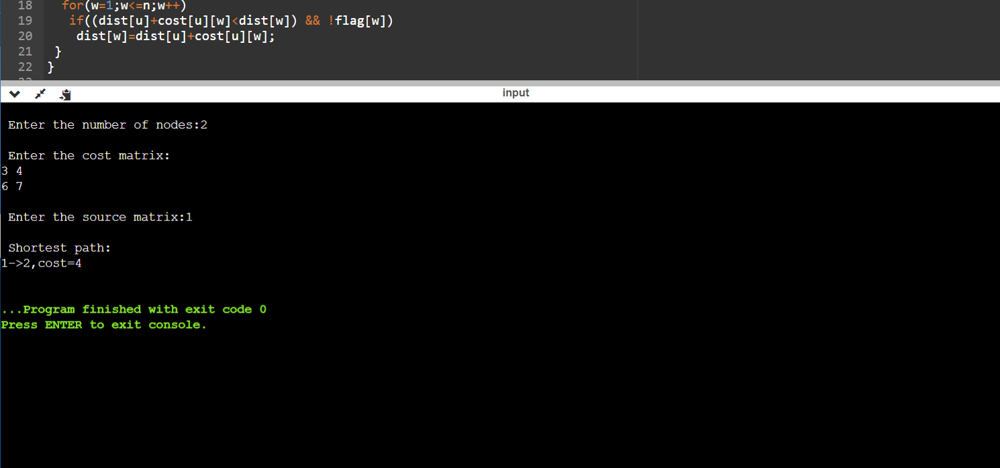

1. **WriteaprogramforcongestioncontrolusingLeakybucketalgorithm. Program:**

#include<bits/stdc++.h> #include<unistd.h>

using namespace std; #definebucketSize500

void bucketInput(int a,int b)

{

if(a >bucketSize)

cout<<"\n\t\tBucket overflow";

else{

sleep(5); while(a>b){

cout<<"\n\t\t"<<b<<" bytes outputted."; a-=b;

sleep(5);

}

if(a > 0)

cout<<"\n\t\tLast "<<a<<" bytes sent\t"; cout<<"\n\t\tBucket outputsuccessful";

}

}

int main()

{

int op,pktSize;

cout<<"Enter output rate : "; cin>>op;

for(int i=1;i<=5;i++)

{

sleep(rand()%10); pktSize=rand()%700;

cout<<"\nPacketno"<<i<<"\tPacketsize="<<pktSize; bucketInput(pktSize,op);

}

cout<<endl; return 0;

}

# Output:

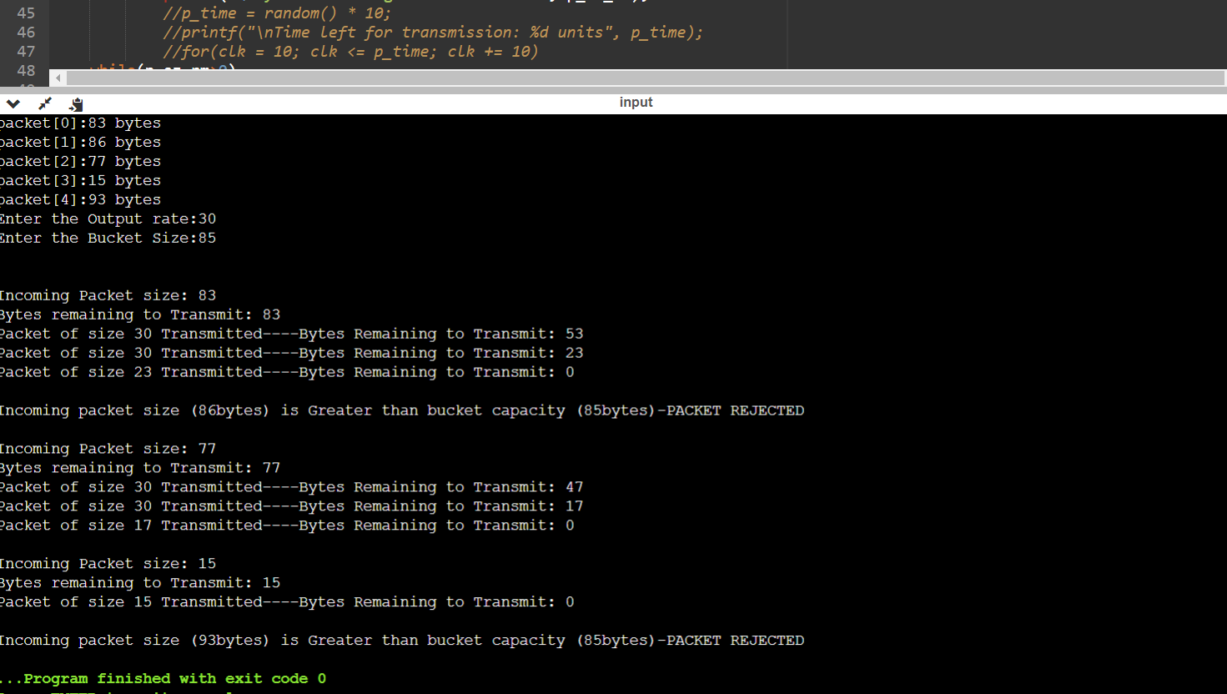

1. **UsingTCP/IPsockets,writeaclient-serverprogramtomakeclient sending the file name and the server to send back the contents of the requested file ifpresent.**

**Program:**

#Client.py

from socket import *

serverName = “127.0.0.1”

serverPort = 12000

clientSocket=socket(AF_INET,SOCK_STREAM) clientSocket.connect((serverName,serverPort)) sentence = input("Enter file name") clientSocket.send(sentence.encode()) filecontents=clientSocket.recv(1024).decode() print ('From Server:', filecontents) clientSocket.close()

#Server.py

from socket import *

serverName=”127.0.0.1”

serverPort = 12000

serverSocket = socket(AF_INET,SOCK_STREAM) serverSocket.bind((serverName,serverPort)) serverSocket.listen(1)

print("Theserverisreadytoreceive") while1:

connectionSocket, addr = serverSocket.accept() sentence = connectionSocket.recv(1024).decode() file=open(sentence,"r")

l=file.read(1024) connectionSocket.send(l.encode()) file.close() connectionSocket.close()

# Output:

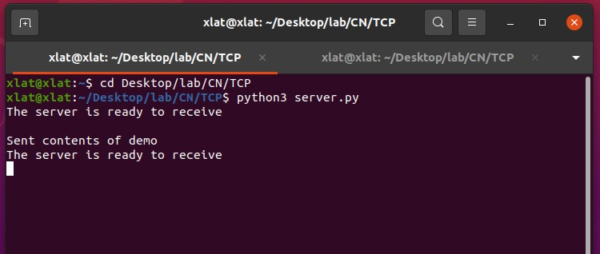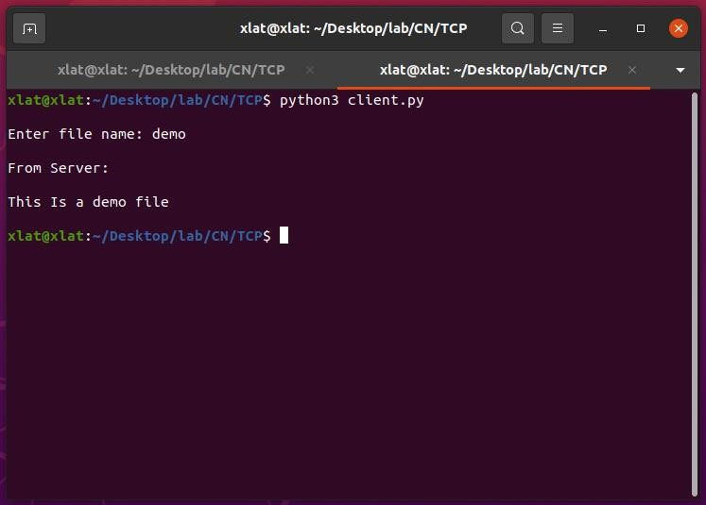

1. **Using UDP sockets, write a client-server program to make client sending the file name and the server to send back the contents of the requested file if present.**

**Program:**

#ClientUDP.py

from socket import * serverName="127.0.0.1"

serverPort = 12000

clientSocket = socket(AF_INET, SOCK_DGRAM) sentence = input("Enter file name")

clientSocket.sendto(bytes(sentence,"utf-8"),(serverName, serverPort)) filecontents,serverAddress = clientSocket.recvfrom(2048)

print ('From Server:', filecontents) clientSocket.close()

#ServerUDP.py

fromsocketimport* serverPort =12000

serverSocket=socket(AF_INET,SOCK_DGRAM) serverSocket.bind(("127.0.0.1", serverPort)) print ("The server is ready toreceive")

while 1:

sentence,clientAddress = serverSocket.recvfrom(2048) file=open(sentence,"r")

l=file.read(2048)

serverSocket.sendto(bytes(l,"utf-8"),clientAddress) print("sent back toclient",l)

file.close()

# Output:

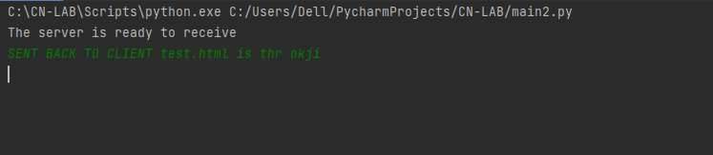

**The server.py is executed first to set up server..and file name is passed**

